Question no: 2

1.pulling ubuntu latest version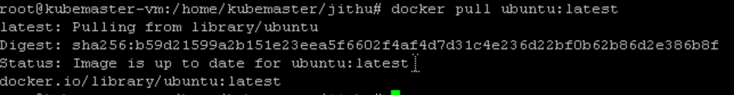

2.Running that ubuntu image $checking the containers

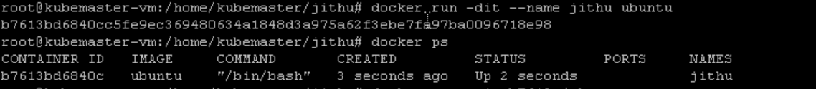

3.Using this command going inside the container and checking the files using /bin/bash:



4.Other way using /bin/sh



5.stopping the resources and deleting it



6.Removed the container



8.Asked to perform some system resources inside the docker container:

Every thing in one frame

Uptime:

